Weekly Assessment for Delta Operations on ESA and CESA-listed Salmonids including Current Delta Hydrologic Conditions
  - Final: Tuesday, January 13, 2026 at 4 PM
Table of contents

Executive Summary
- Entrainment management season is active.
- Season Loss: 0 (0.00% of threshold) DNA Winter-run, 0 (0.00% of threshold) Hatchery Winter-run, 43.91 (0.83% of threshold) Natural Steelhead, 122.07 (3.42% of threshold) Hatchery Steelhead, and 872.69 (10.84% of threshold) Spring-run Surrogates.
- Winter-run presence in the Delta is high (historical peak).
- Steelhead presence in the Delta is increasing.

1 Current Delta Hydrologic Conditions

1.1 Operational and Regulatory Conditions
Entrainment management is the current controlling factor. See most recent weekly outlook for more information.

1.2 Current Conditions
Most recent inflow at Freeport in the Sacramento River and Vernalis in the San Joaquin River is 65,994 and 2,951 cfs respectively. Most recent 1-day, 5-day, and 14-day OMRI measurements were -4,900, -4,909, and -5,061 respectively, and most recent export data were 3,551 for Jones Pumping Plant and 1,734 for Henry O. Banks Pumping Plant.
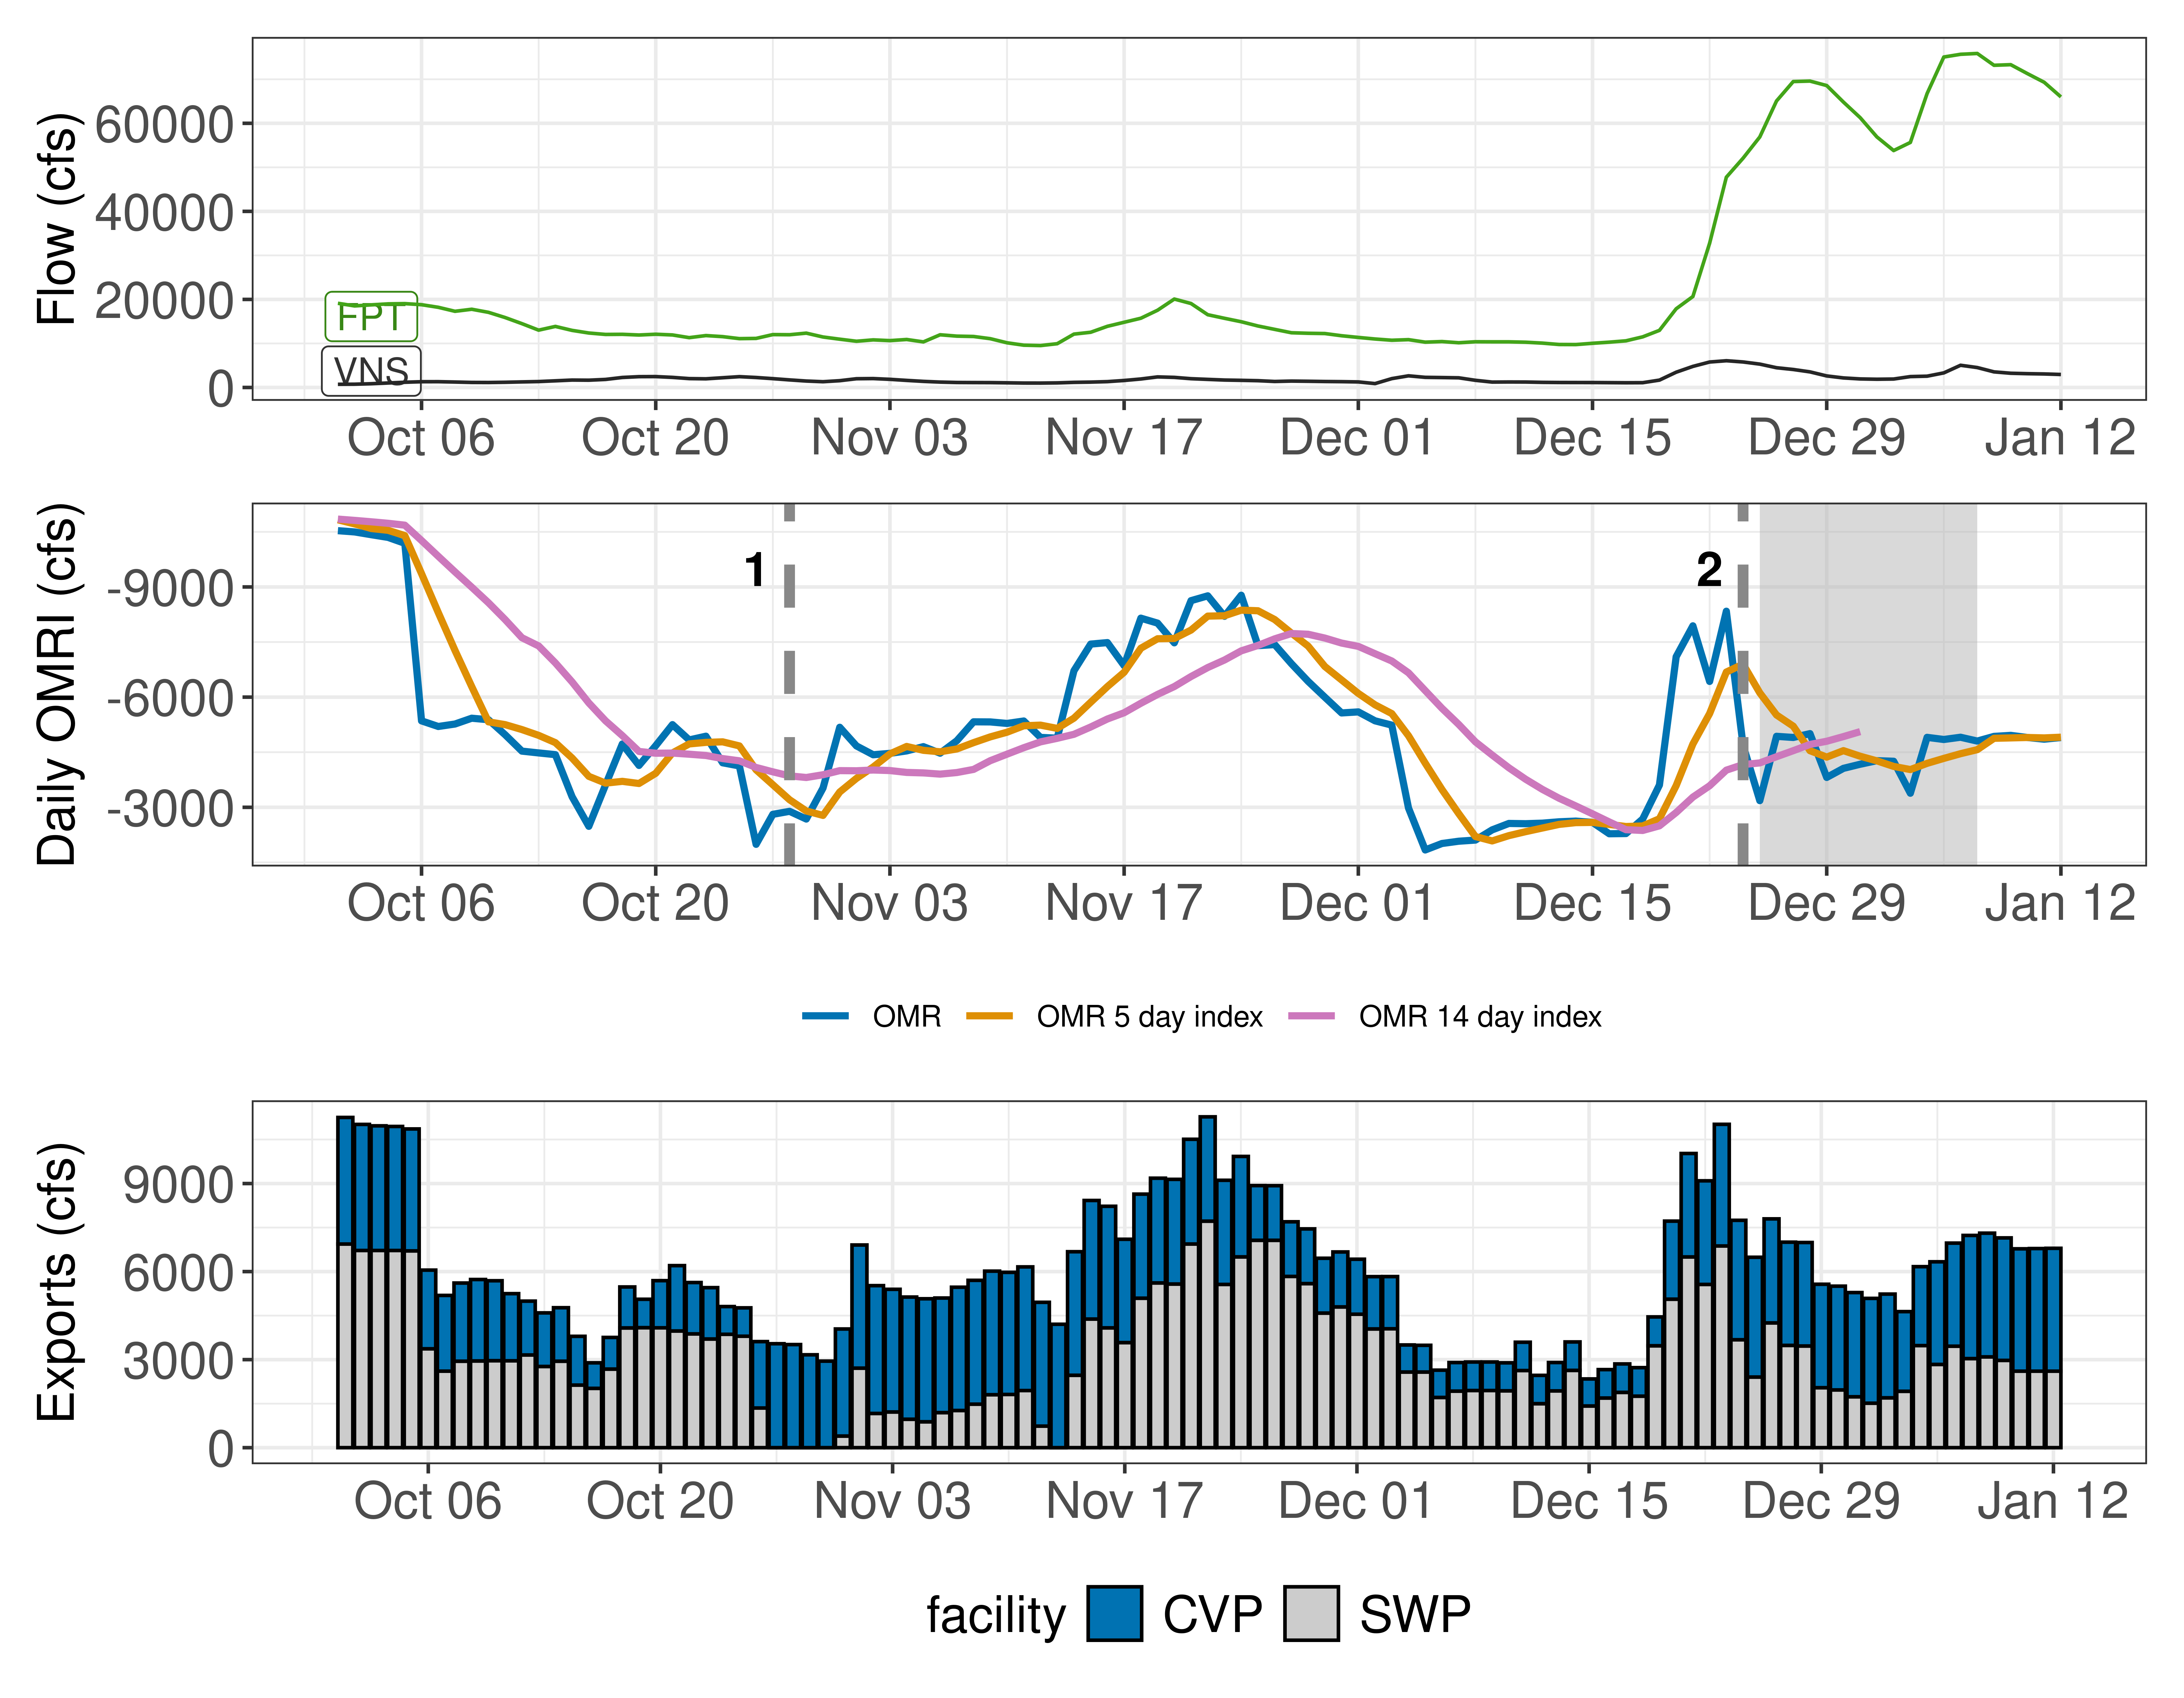
Figure 1: Operations and Action Summary, WY 2026. The numbers and dashed lines in the OMRI plot indicate different triggers (see Table 1), with shading representing specific action periods. OMRI data (colored lines) calculated by SacPAS, Freeport (FPT) and Vernalis (VNS) flow data from CDEC, and CVP (TRP) and SWP (HRO) exports data from CDEC.
Table 1: Summary of Actions and Triggers, WY 2026
Label | Action | Date Triggered | Date Implemented | Number Days Implemented | Regulation
1 | DCC Gate Closure | 10/28/2025 | 2025-10-30 | Ongoing | DCC gates
2 | First Flush | 12/24/2025 | 2025-12-25 | 14 days | Entrainment Management

1.3 Zone of Influence
Zone of Influence (ZOI) analysis is discussed in detail in the December 22 assessment. Current conditions were queried from most recent Freeport flow data on the Sacramento River and Vernalis flow data on the San Joaquin river from SacPAS. Forecasted flows were queried from short range deterministic flows provided by the California Nevada River Forecast Center.
Current conditions at Freeport and Vernalis indicate that delta hydrology falls within the ‘himed’ category. Forecasted conditions averaged across the next 7 days falls within the ‘himed’ category.
The altered channel length for the current “himed” hydrology is 23, 53, 118 and 111 kilometers (km) across OMR bins of -2000, -3500, -5000 and <-5500 respectively. The altered channel length for forecasted “himed” hydrology is 23, 53, 118 and 111 kilometeres (km) across OMR bins of -2000, -3500, -5000 and <-5500 respectively.
Change in altered channel length between OMR levels is 88 km for current conditions and 88 km for forecasted conditions indicating that ZOI impacts across OMR scenarios would not change between current and forecasted conditions. Across the nine hydrology bins, changes in altered channel length across OMR scenarios are moderate (between 25th and 75th percentiles) for both current and forecasted hydrology.
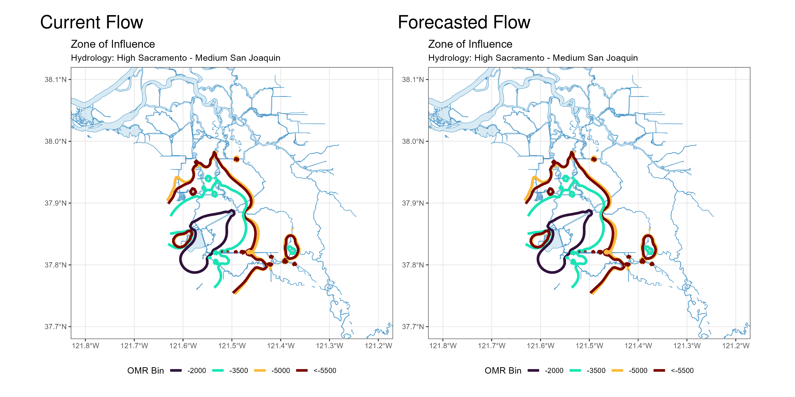
Figure 2: Modeled Zone of Influence at different OMRI scenarios based on current inflow hydrology (left) and forecasted inflow hydrology (right) from the Sacramento River and San Joaquin River

2 Assessment for Delta Operations on Salmonids
For more detailed data on salmonid conditions in the Delta see corresponding webpage on SacPAS.

2.1 Natural Winter-run Chinook

2.1.1 Juvenile Production Estimate
The Juvenile Production Estimate for winter-run is 1,057,452 for the current water year.

2.1.2 Current Status
Entry Timing - Historically, as of Jan 12, 75% of length-at-date (LAD) winter-run have entered the delta based on Knights Landing RST catch, 2% have exited the delta based on Chipps Island Trawl Catch, and 0% of DNA confirmed winter-run have been salvaged.
Table 2
Species | Red Bluff Diversion Dam | Tisdale RST | Knights Landing RST | Sac Trawl (Sherwood) | Chipps Island Trawl | Salvage
Chinook, LAD Winter-run, Unclipped | 98% | 78% | 75% | 38% | 2% | 15%
Chinook, DNA Winter-run, Unclipped (Water Year) | NA | NA | NA | NA | NA | 0%

Red Bluff Diversion Dam Passage Estimate - As of Dec 16 estimated passage to date of LAD winter run at Red Bluff Diversion is approximately 3.61 million fish. * Note that outmigration timing overlaps with spring run migrating fish, and true winter-run abundance likely differs from these estimates.
Delta Monitoring - Total catch of LAD winter run at RSTs at Delta Entry (Tisdale, Knights Landing, Lower Sacramento River) between Dec 30 and Jan 12 is 190 individuals. Total catch at Sacramento Trawl and Beach Seines in the delta between Dec 30 and Jan 12 is 15 individuals. Total catch at Delta Exit at Chipps Island between Dec 30 and Jan 08 is 1 individuals.

2.1.3 Annual Loss
The annual Loss threshold for natural winter-run is 1% of the jpe or 10,574.52 fish. As of January 12, cumulative loss of genetically confirmed winter-run is 0 or 0.00% of the annual loss threshold. Cumulative loss in the past 7 days has been 0.
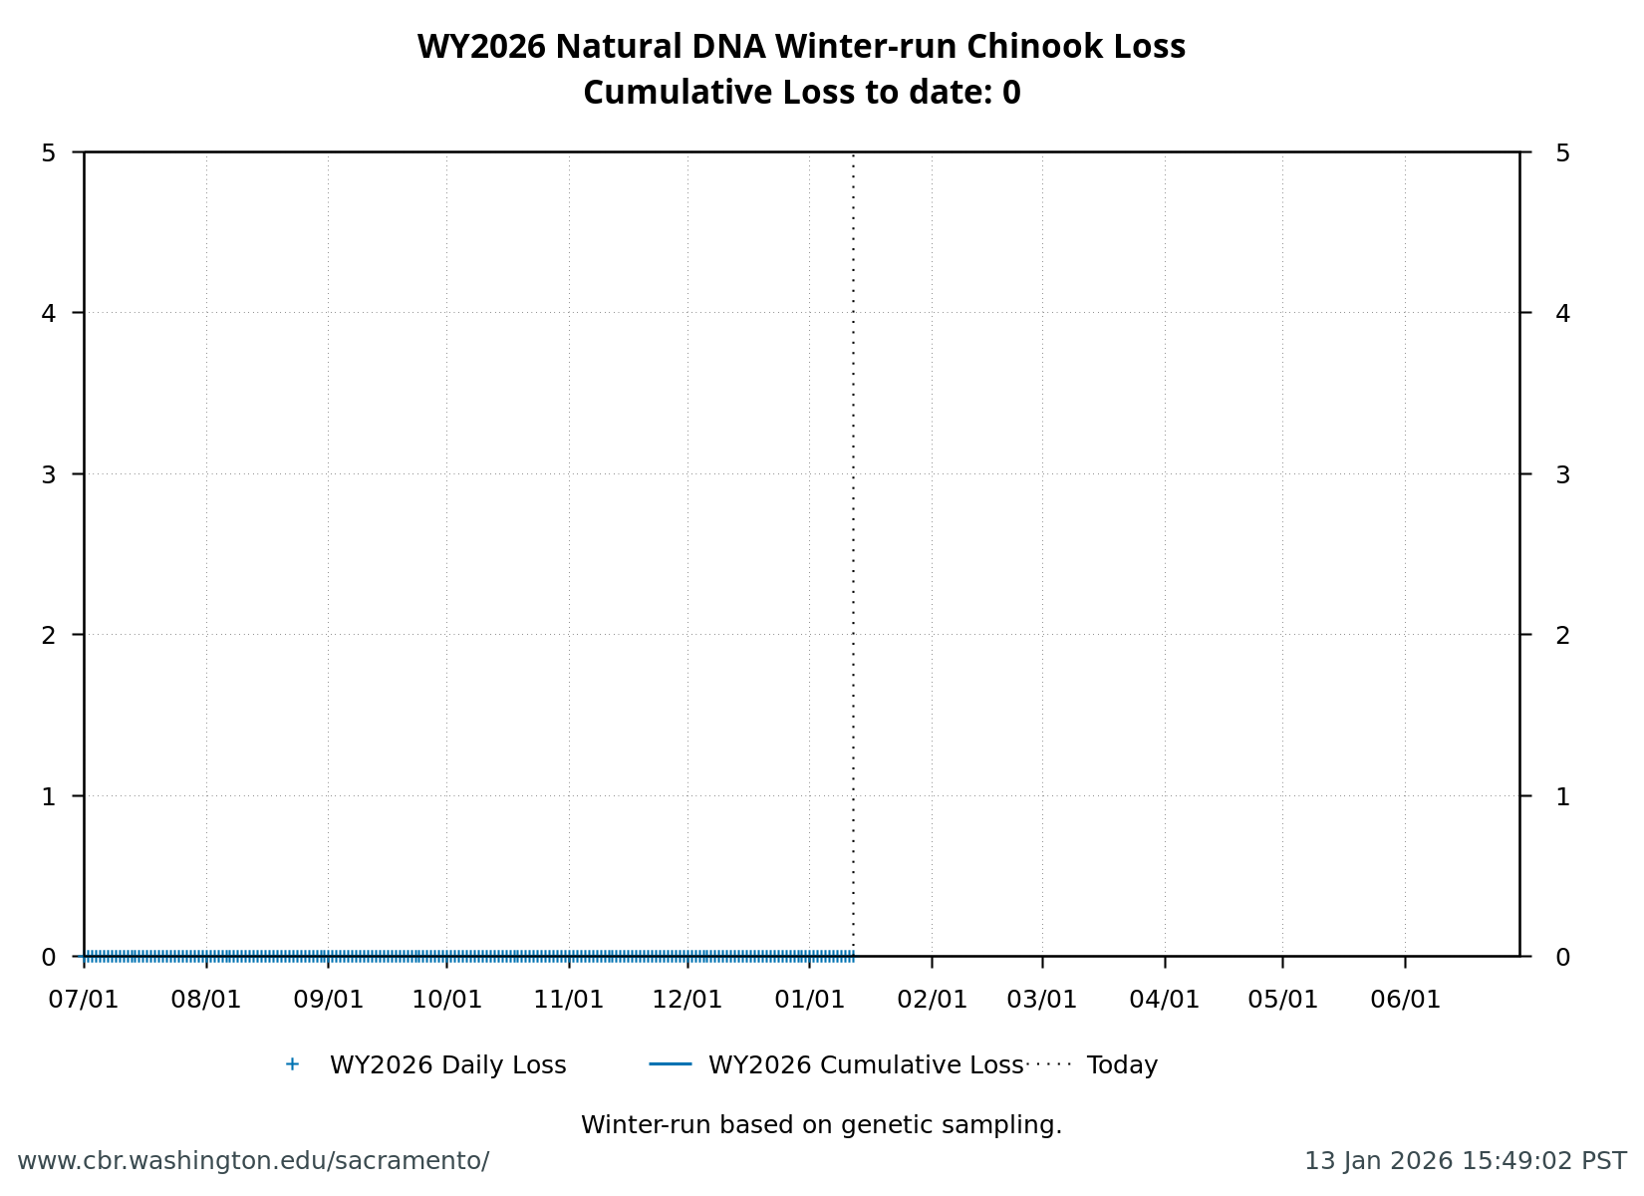
Figure 3: Cumulative loss of natural-origin winter-run for WY 2026. Cumulative loss is based on genetically confirmed winter-run captured in salvage or length-at-date winter-run in which genetic confirmation was unable to be obtained

2.1.4 STARS
The Delta STARS Model is an individual-based simulation model that predicts survival, travel time, and routing of juvenile salmon migrating through the Sacramento–San Joaquin River Delta. This model gives insight into survival and routing patterns of winter-run based on most current conditions.
As of January 12, overall through delta STARS estimated survival probability (with 80% credible intervals) is 0.73 (0.66-0.8) placing it in the 94th percentile of historical STARS survival estimates for the month of January (WYs 2018-2025). STARS estimated routing and survival probabilities (with 80% credible intervals) into the interior delta are 0.09 (0.08-0.11) and 0.61 (0.45-0.76), respectively, corresponding to the 6th and 90th percentiles of historical January estimates (WYs 2018-2025).
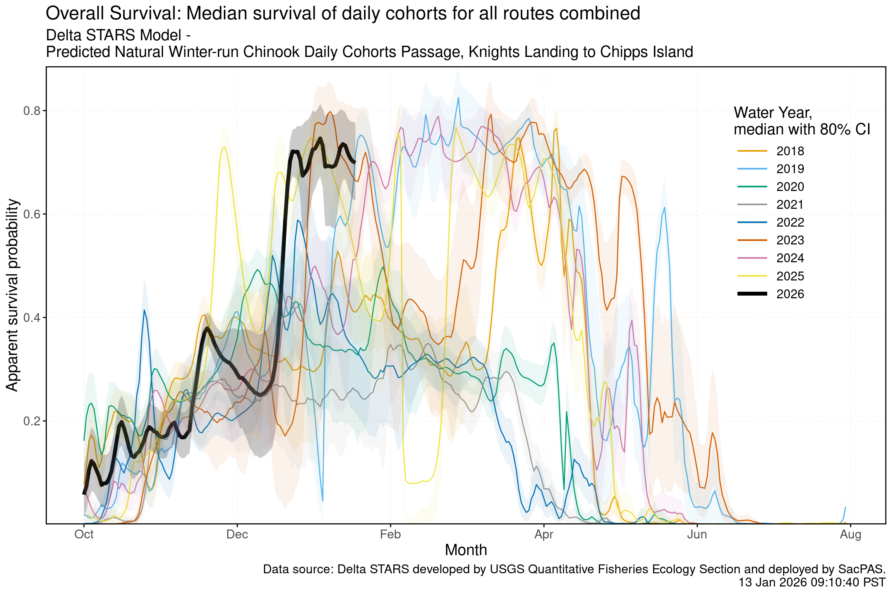
Figure 4: Estimated overall winter-run survival from Knights Landing to Chipps Island. Black line indicates the current water-year, and other colored lines correspond to past water years.
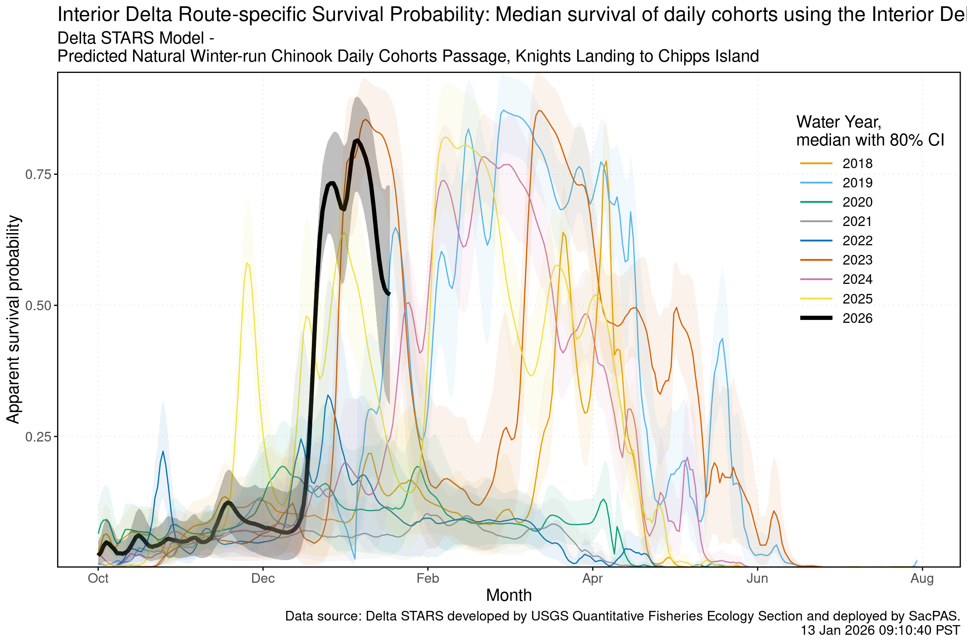
Figure 5: Estimated survival from Knights Landing to Chipps Island of simulate winter-run cohorts that route through the interior delta. Black line indicates the current water-year, and other colored lines correspond to past water years.
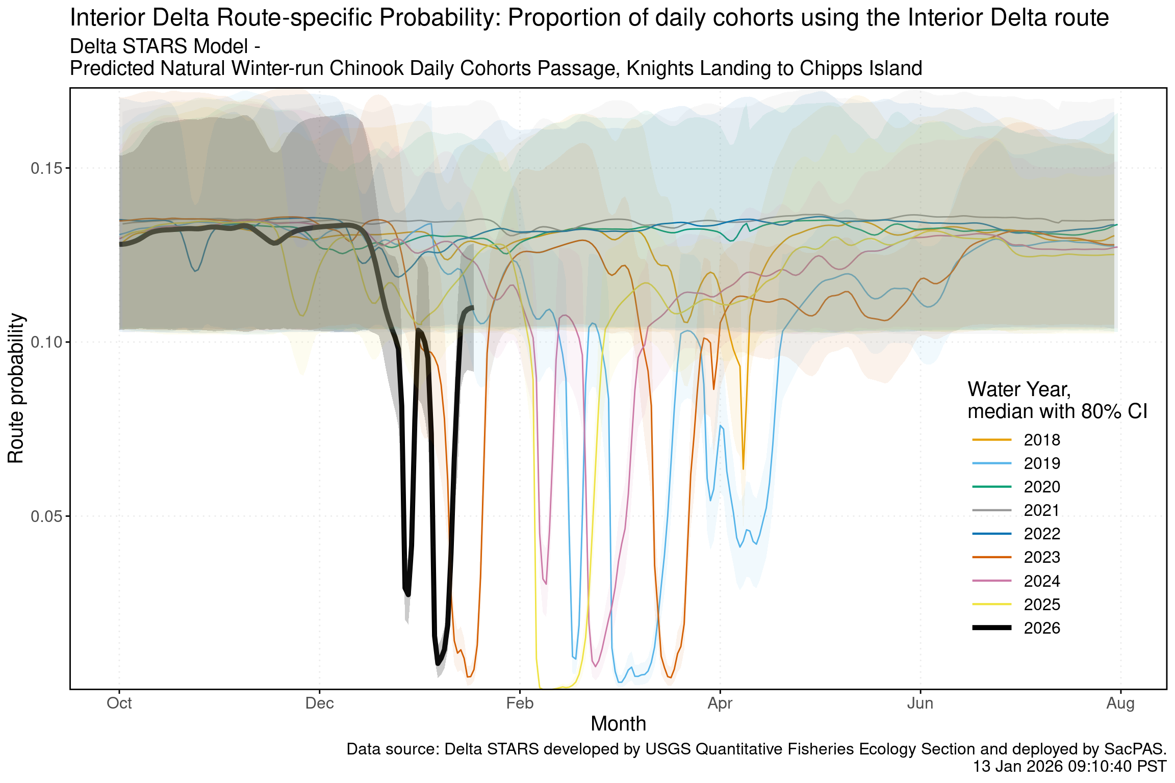
Figure 6: Estimated probability of winter-run routing into the interior delta. Black line indicates the current water-year, and other colored lines correspond to past water years.

2.2 Hatchery Winter-run Chinook

2.2.1 Hatchery Releases
To date, no winter-run Livingstone hatchery releases have occurred in WY 2026

2.2.2 Juvenile Production Estimate
The Juvenile Production Estimate for hatchery winter-run is 130,096 for Livingston Stone releases.

2.2.3 Annual Loss
To date, no loss has occurred as no hatchery winter-run have been released.

2.3 Natural-origin Central Valley Steelhead

2.3.1 Current Status
Delta Entry Timing - Historically, as of Jan 12, 16% of CCV steelhead have entered the delta based on Knights Landing RST catch, 1% have exited the delta based on Chipps Island Trawl Catch, and 6% have been salvaged.
Table 3: Average Percent of annual emigrating population for unclipped CCV steelhead captured at the following locations and salvaged at SWP and CVP Delta facilities for the past 10 years.
Species | Red Bluff Diversion Dam | Tisdale RST | Knights Landing RST | Sac Trawl (Sherwood) | Chipps Island Trawl | Salvage
Steelhead, Unclipped | 1% | 15% | 16% | 0% | 1% | 6%

Delta Monitoring - Total catch of LAD winter run at RSTs at Delta Entry (Tisdale, Knights Landing, Lower Sacramento River) between Dec 30 and Jan 12 is 0 individuals. Total catch at Sacramento Trawl and Beach Seines in the delta between Dec 30 and Jan 12 is 0 individuals. Total catch at Delta Exit at Chipps Island between Dec 30 and Jan 08 is 0 individuals.

2.3.2 Annual Loss
As of January 12, cumulative loss of unclipped steelhead is 43.91 or 0.83% of the incidental take limit in the NMFS Biological Opinion. Cumulative loss in the past 7 days has been 97.59.
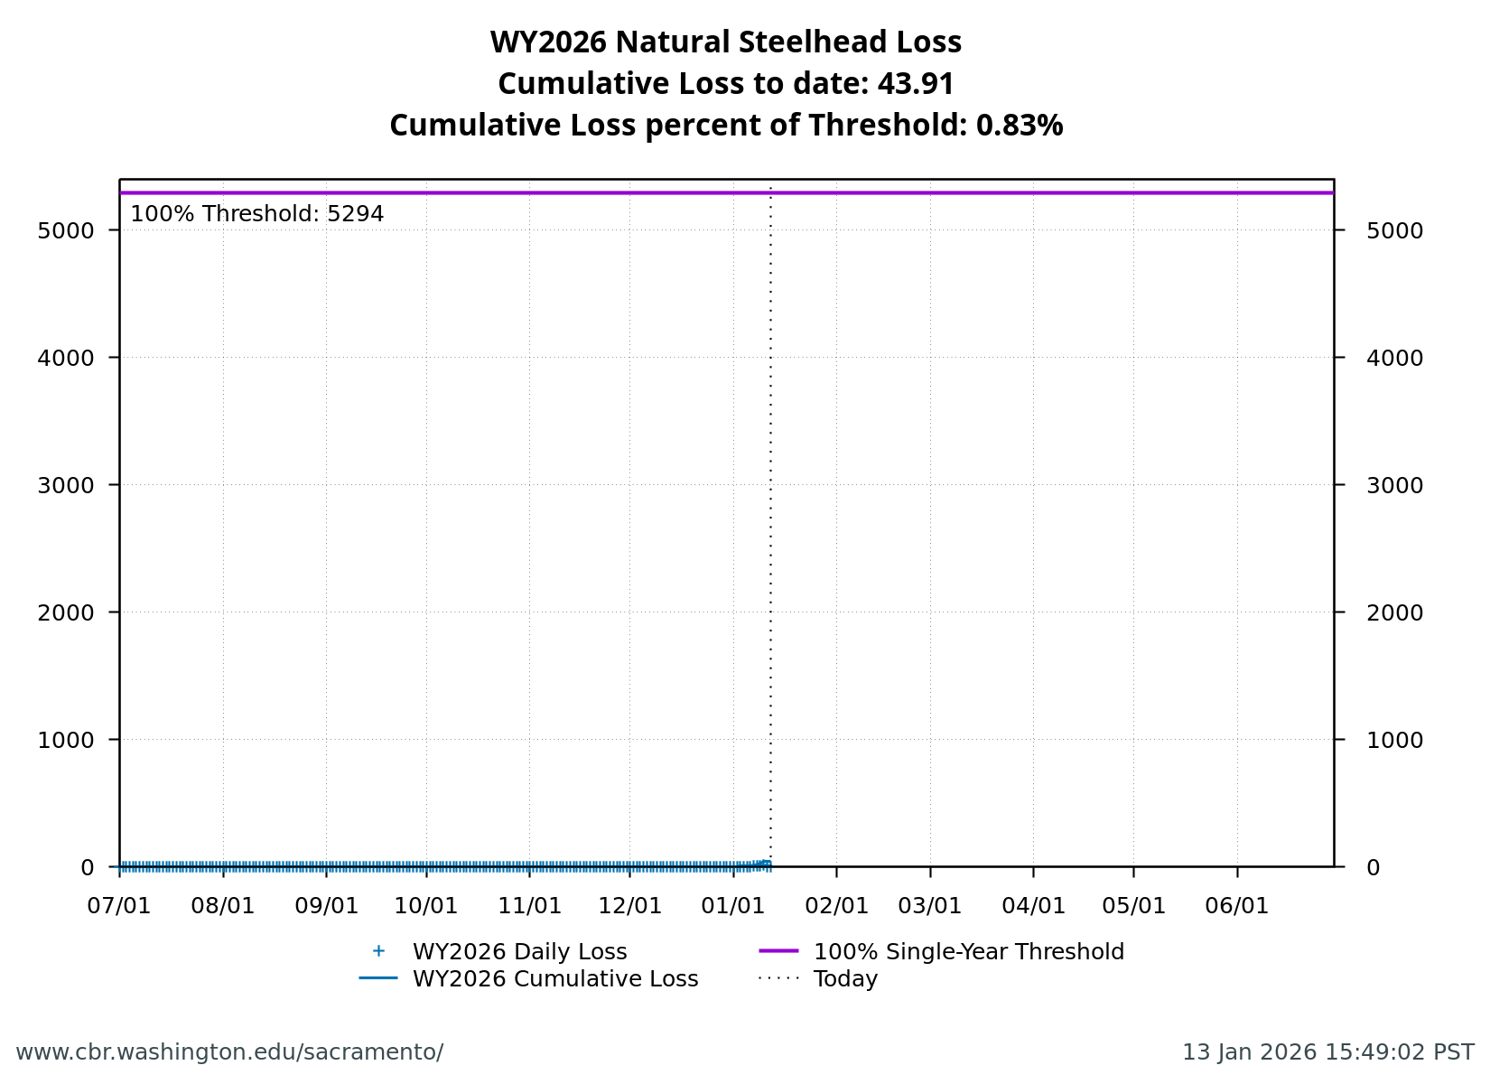
Figure 7: Cumulative loss of natural-origin steelhead for WY 2026.

2.4 Hatchery-origin Central Valley Steelhead

2.4.1 Surrogate Releases
There have been a total of 2 releases totaling 878,848 steelhead in Water Year 2026. JPE for the hatchery releases as of today is 356,526 based on estimated survivals using forecasted water year types (see details in table below). The annual loss threshold, equal to 1% of the JPE, is currently 3565, but is subject to change with additional steelhead releases.
Table 4: Summary of steelhead hatchery releases in Water Year 2026
Hatchery | Date of Release | Mean Fork Length (mm) | Number Released | Estimated Survival | Juvenile Production Estimate
Nimbus | 2025-11-02 | 223 | 233,109 | 72% | 167,838
Coleman | 2025-12-19 | 195 | 645,739 | 29% | 188,688

Total loss of hatchery-origin steelhead is 122.07 or 3.42% of the threshold. *Note that hatchery origin of salvaged fish can not be determined at this time and salvage is based on the assumption of similar routing and survival probabilities of individual hatchery releases.
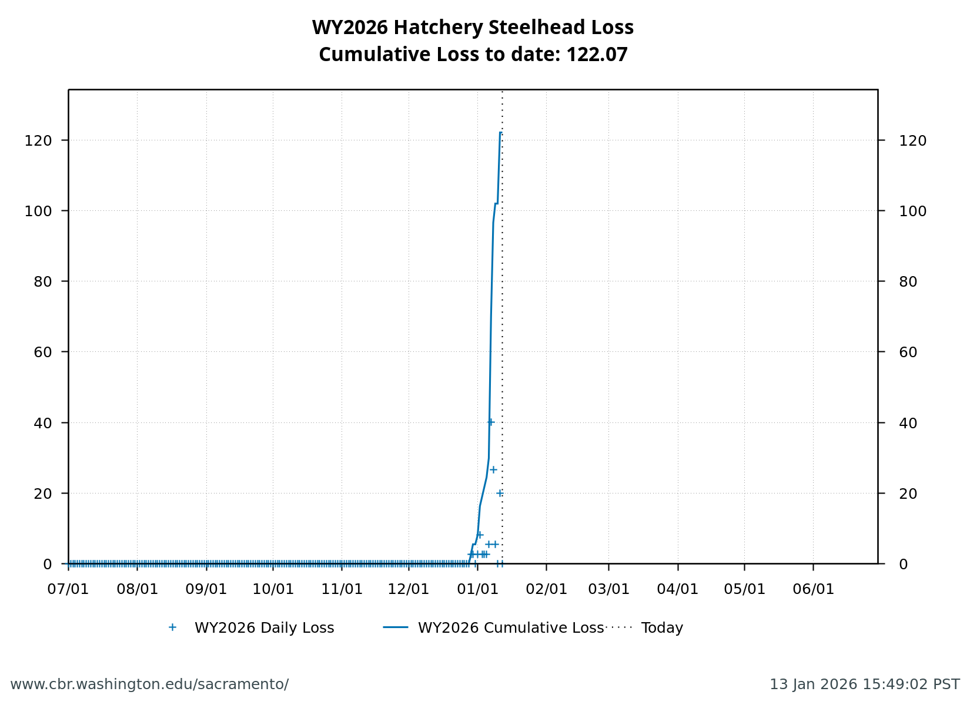
Figure 8: Cumulative loss of hatchery steelhead for WY 2026.

2.5 Spring-run

2.5.1 Current Status
Delta Entry Timing- Historically, as of Jan 12, 26% of LAD spring run have entered the delta based on Knights Landing RST catch, 0% have exited the delta based on Chipps Island Trawl Catch, and 0% have been salvaged.
Table 5: Average Percent of annual emigrating population for LAD Spring-run Chinook Salmon captured at the following locations and salvaged at SWP and CVP Delta facilities for the past 10 years.
Species | Red Bluff Diversion Dam | Tisdale RST | Knights Landing RST | Sac Trawl (Sherwood) | Chipps Island Trawl | Salvage
Chinook, LAD Spring-run, Unclipped | 12% | 14% | 26% | 2% | 0% | 0%

Red Bluff Diversion Dam Passage Estimate - As of Dec 16 estimated passage to date of LAD spring run at Red Bluff Diversion is approximately 0.01 million fish. * Note that outmigration timing overlaps with winter run and fall run outmigration, and true spring run abundance likely differs from these estimates.
Delta Monitoring- Total catch of LAD winter run at RSTs at Delta Entry (Tisdale, Knights Landing, Lower Sacramento River) between Dec 30 and Jan 12 is 172 individuals. Total catch at Sacramento Trawl and Beach Seines in the delta between Dec 30 and Jan 12 is 0 individuals. Total catch at Delta Exit at Chipps Island between Dec 30 and Jan 08 is 0 individuals.

2.5.2 Spring-run Surrogate Releases
A total of 805,323 spring-run surrogate fish have been released in Water Year 2026. See details in table below.
Table 6: Spring-run Chinook Salmon Surrogate Releases.
Hatchery | Release Date | Type | # of CWT Fish Released | Confirmed Loss | CWT Codes
Coleman NFH | 2025-11-13 | Yearling | 143346 | 8.7 | 056808, 056809
Coleman NFH | 2025-11-17 | Yearling | 75119 | 0.0 | 056810
Coleman NFH | 2025-12-17 | Yearling | 468876 | 639.9 | 053700, 056806, 056811, 056812, 056814, 056815, 056817
Coleman NFH | 2025-12-22 | Yearling | 60873 | 224.1 | 056813
Coleman NFH | 2026-01-08 | Yearling | 57109 | 0.0 | 056816

2.5.3 Annual Loss
The annual loss threshold is 1% of the total releases, which equals 8,053 fish. As of January 12, cumulative loss is 872.69 fish or 10.84% of the annual loss threshold.

2.6 Loss Prediction and Trajectories
The following figures display the cumulative loss trajectories relative to historical years (“Spaghetti Plots”) and the current loss predictor model outputs for Winter-run Chinook Salmon and Steelhead.
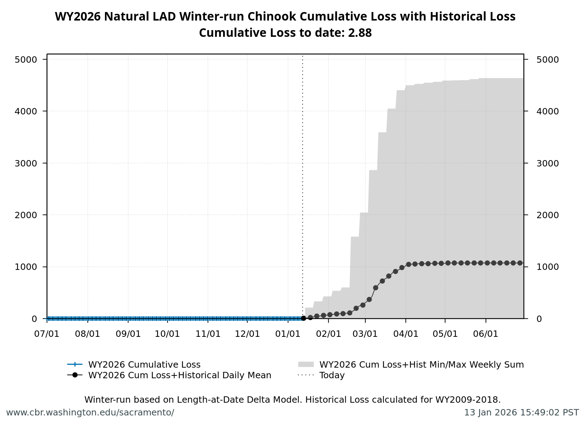
Figure 9: Natural LAD Winter-Run Chinook Salmon Loss Cumulative to Date with historical years and Single Year Loss Thresholds.

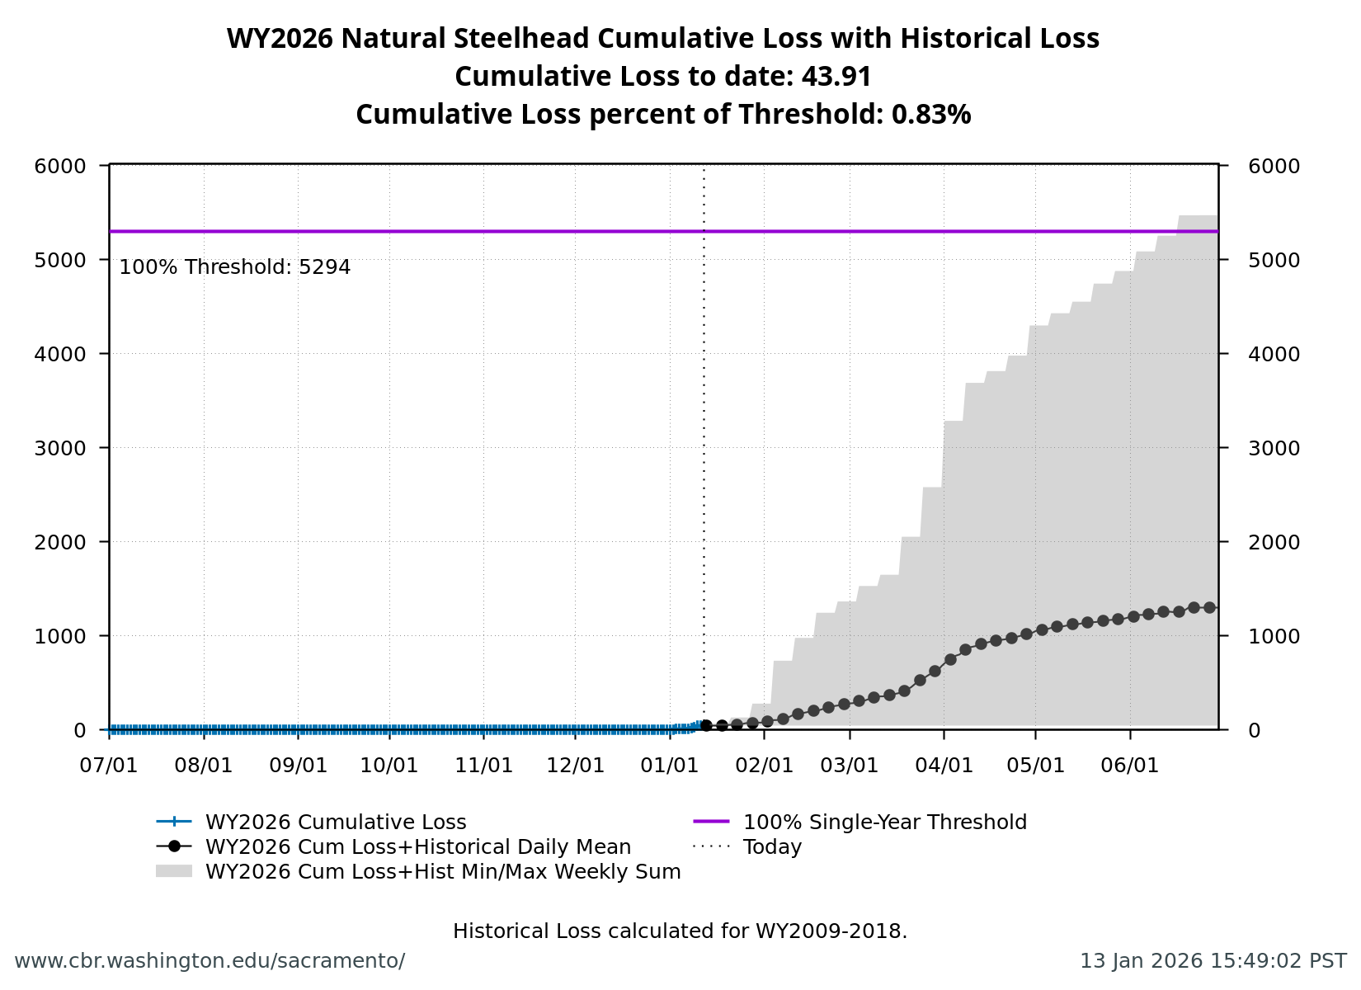
Figure 10: Natural Central Valley Steelhead Loss Cumulative to Date with historical years and Single Year Loss Thresholds.

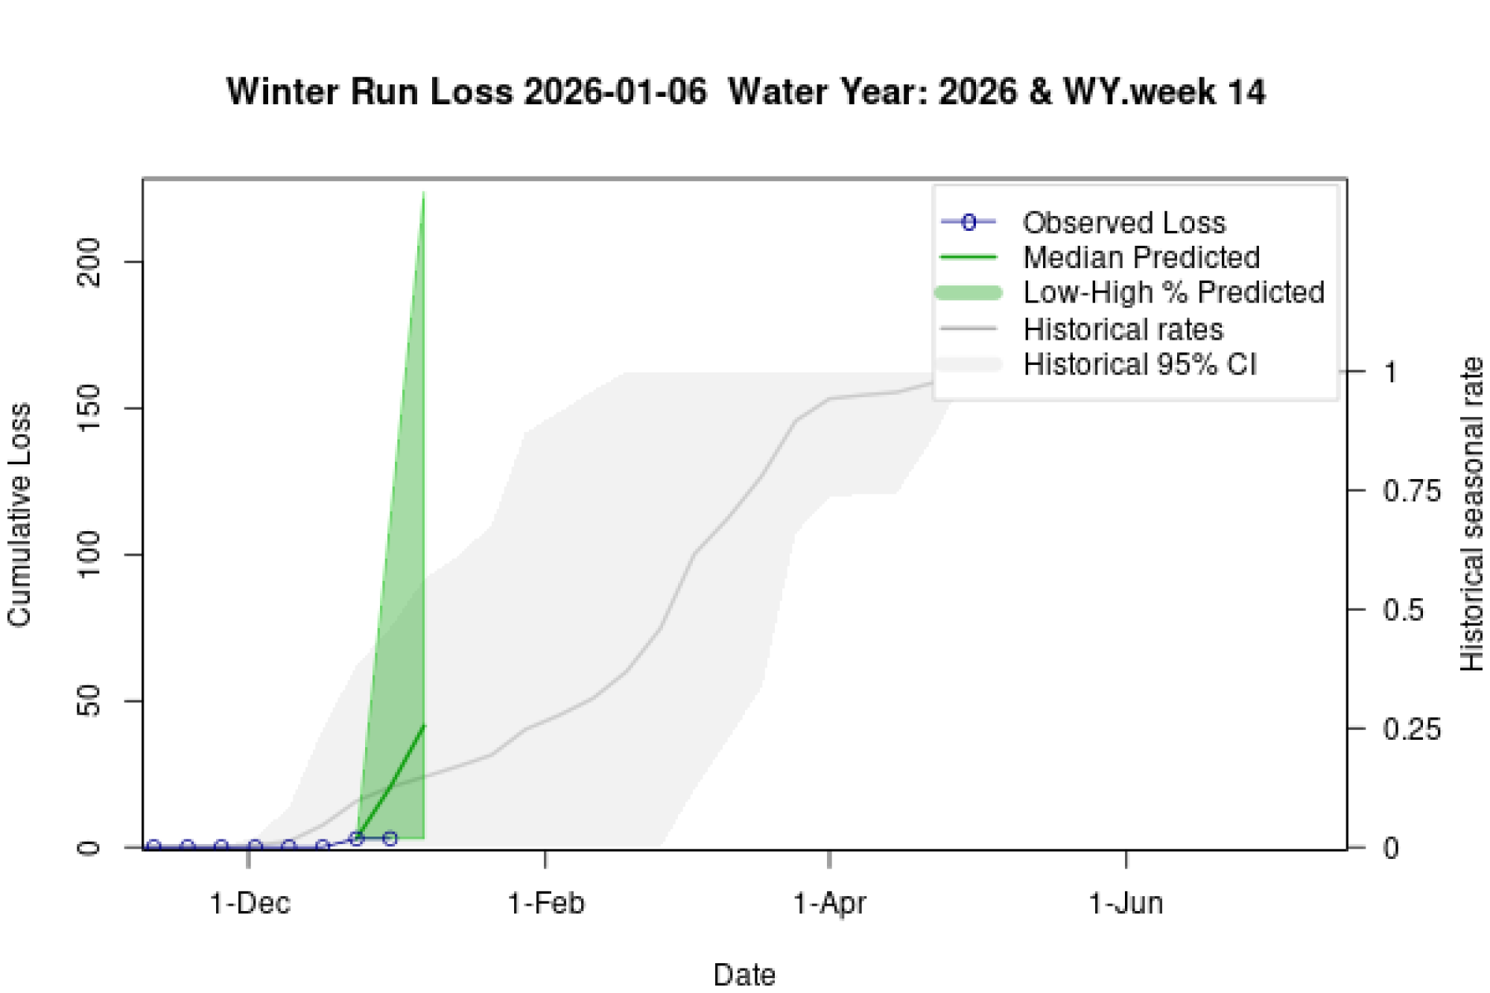
Figure 11: Estimates of Winter-run Chinook Loss generated by Loss and Salvage Predictor tool.

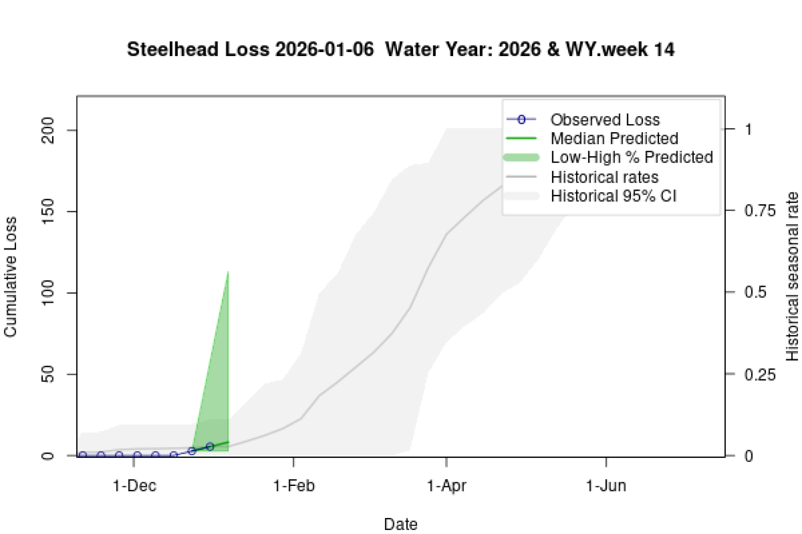
Figure 12: Estimates of Steelhead Loss generated by Loss and Salvage Predictor tool.

2.7 Evaluation
- What is the probability of exceeding natural or hatchery winter-run Chinook Salmon loss thresholds in the upcoming week?
- LOW RISK: Cumulative loss is currently 0% of the threshold. Current trajectory suggests the threshold is unlikely to be exceeded in the upcoming week.
- What is the probability of spring-run hatchery Chinook Salmon loss thresholds in the upcoming week?
- LOW RISK: Cumulative loss is currently 10.8% of the threshold. Current trajectory suggests the threshold is unlikely to be exceeded in the upcoming week.
- What is the probability of hatchery Steelhead loss thresholds in the upcoming week?
- LOW RISK: Cumulative loss is currently 3.4% of the threshold. Current trajectory suggests the threshold is unlikely to be exceeded in the upcoming week.

