Current Delta Hydrologic Conditions
Final: Tuesday, January 13, 2026 at 4 PM

Operational and Regulatory Conditions
Entrainment management is the current controlling factor. See most recent weekly outlook for more information.

Current Conditions
Most recent inflow at Freeport in the Sacramento River and Vernalis in the San Joaquin River is 65,994 and 2,951 cfs respectively. Most recent 1-day, 5-day, and 14-day OMRI measurements were -4,900, -4,909, and -5,061 respectively, and most recent export data were 3,551 for Jones Pumping Plant and 1,734 for Henry O. Banks Pumping Plant.
Figure 1: Operations and Action Summary, WY 2026. The numbers and dashed lines in the OMRI plot indicate different triggers (see Table 1), with shading representing specific action periods. OMRI data (colored lines) calculated by SacPAS, Freeport (FPT) and Vernalis (VNS) flow data from CDEC, and CVP (TRP) and SWP (HRO) exports data from CDEC.
Table 1: Summary of Actions and Triggers, WY 2026
Label | Action | Date Triggered | Date Implemented | Number Days Implemented | Regulation
1 | DCC Gate Closure | 10/28/2025 | 2025-10-30 | Ongoing | DCC gates
2 | First Flush | 12/24/2025 | 2025-12-25 | 14 days | Entrainment Management

Zone of Influence
Zone of Influence (ZOI) analysis is discussed in detail in the December 22 assessment. Current conditions were queried from most recent Freeport flow data on the Sacramento River and Vernalis flow data on the San Joaquin river from SacPAS. Forecasted flows were queried from short range deterministic flows provided by the California Nevada River Forecast Center.
Current conditions at Freeport and Vernalis indicate that delta hydrology falls within the ‘himed’ category. Forecasted conditions averaged across the next 7 days falls within the ‘himed’ category.
The altered channel length for the current “himed” hydrology is 23, 53, 118 and 111 kilometers (km) across OMR bins of -2000, -3500, -5000 and <-5500 respectively. The altered channel length for forecasted “himed” hydrology is 23, 53, 118 and 111 kilometeres (km) across OMR bins of -2000, -3500, -5000 and <-5500 respectively.
Change in altered channel length between OMR levels is 88 km for current conditions and 88 km for forecasted conditions indicating that ZOI impacts across OMR scenarios would not change between current and forecasted conditions. Across the nine hydrology bins, changes in altered channel length across OMR scenarios are moderate (between 25th and 75th percentiles) for both current and forecasted hydrology.
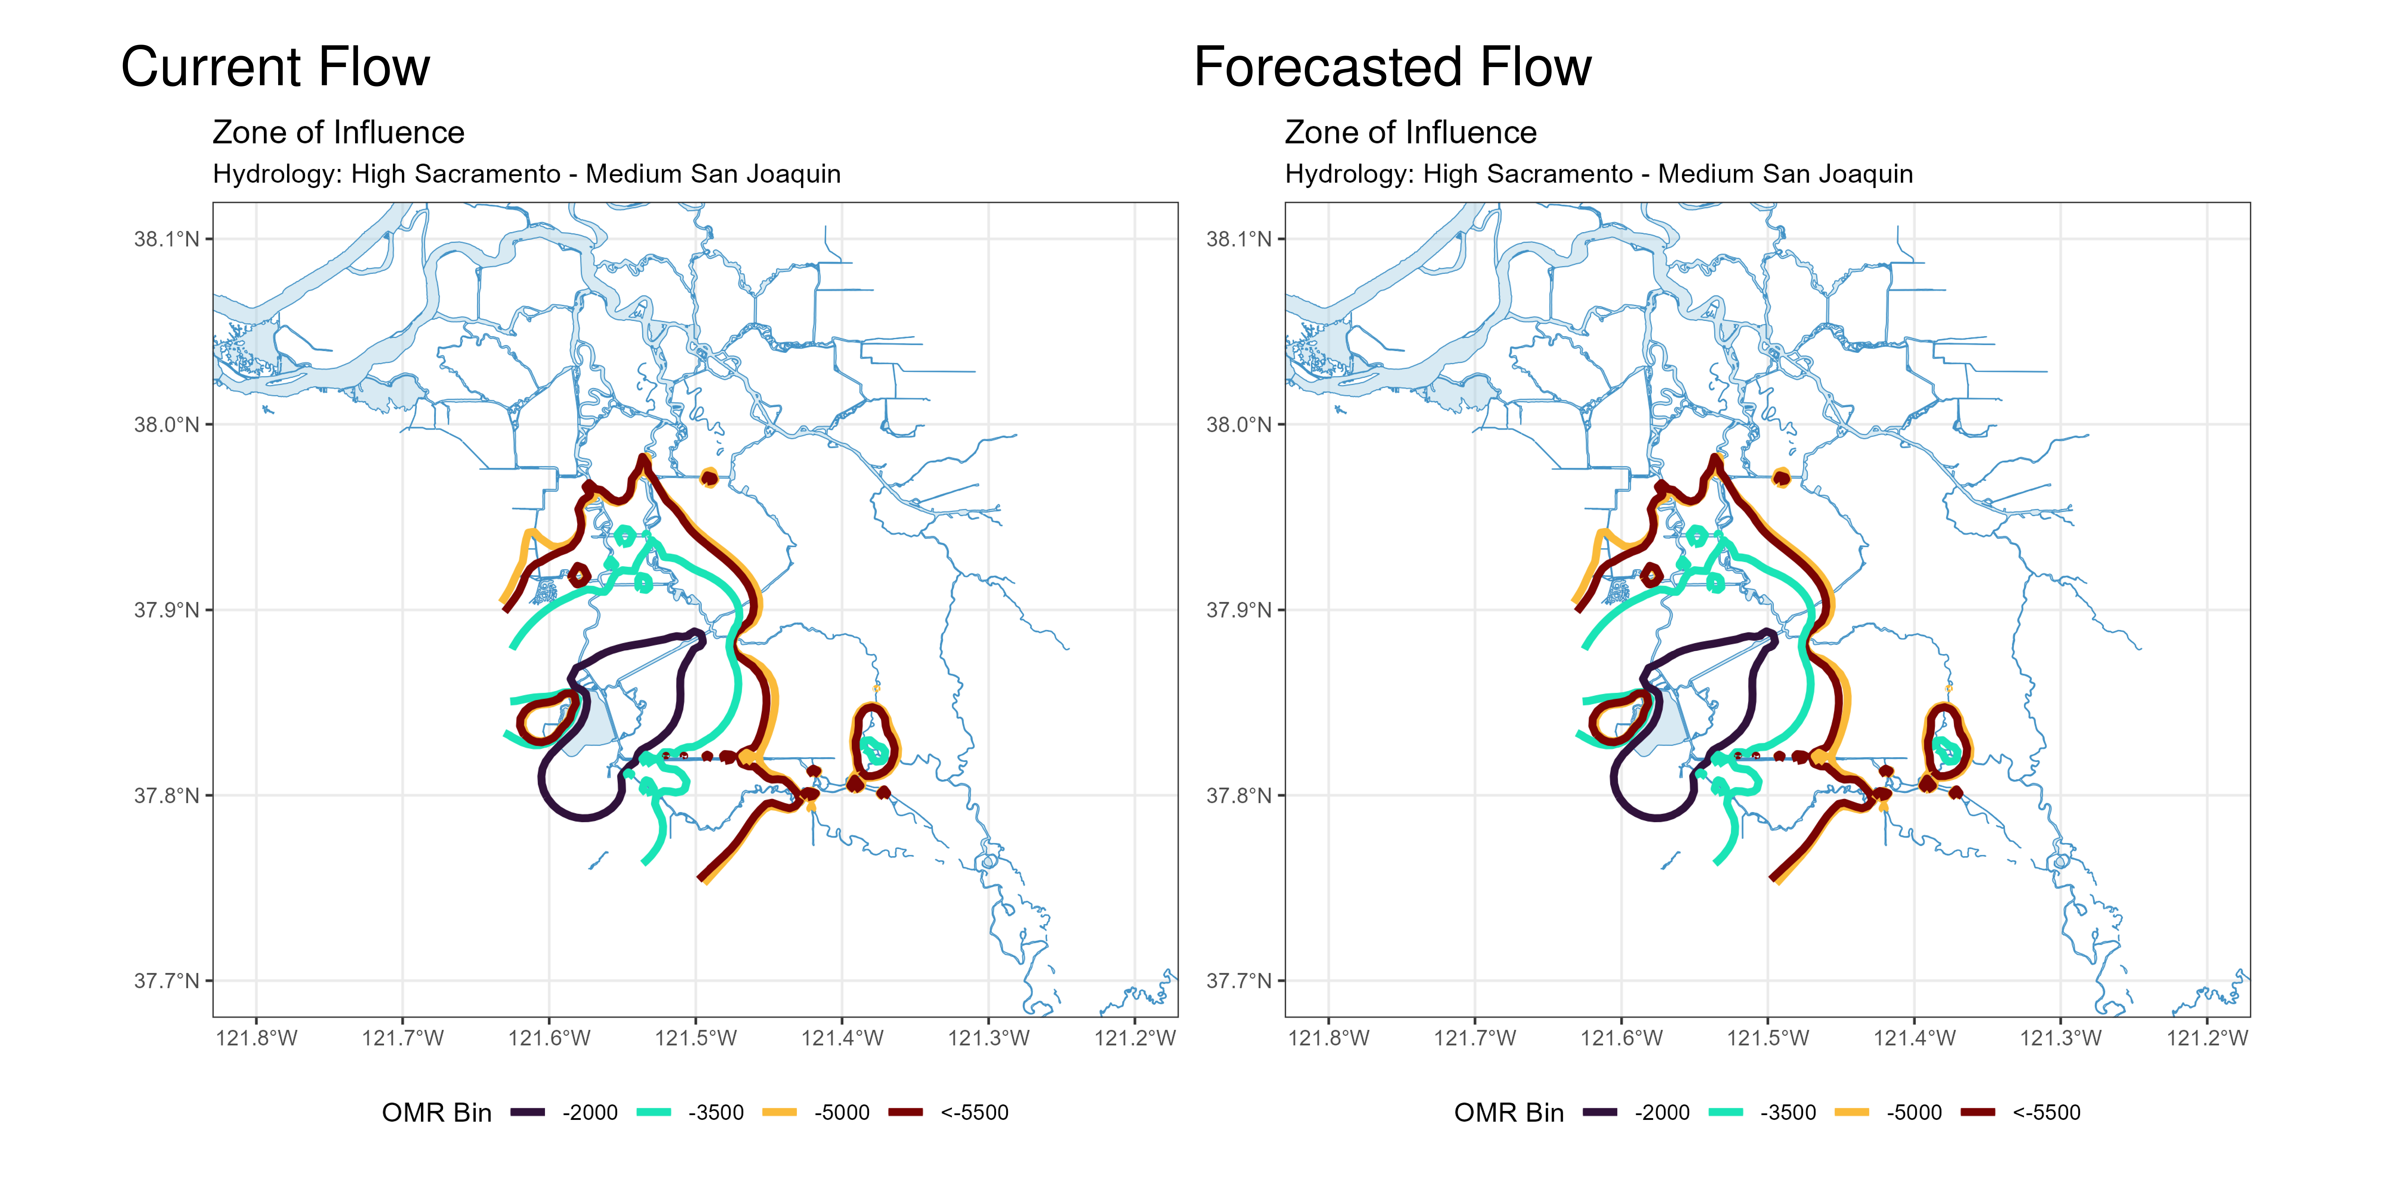
Figure 2: Modeled Zone of Influence at different OMRI scenarios based on current inflow hydrology (left) and forecasted inflow hydrology (right) from the Sacramento River and San Joaquin River

