Weekly Assessment for Delta Operations on ESA and CESA-listed Osmerids
Final: Tuesday, January 13, 2026 at 4 PM

Executive Summary
- The First flush action implementation period ended on 1/7/26. Entrainment management is currently active.
- Delta smelt are primarily distributed west of the confluence, in Suisun Marsh
- No Delta smelt or longfin smelt salvage has been observed this water year
- Turbidity in the central/south Delta is moderate.

Operational and Regulatory Conditions
- See current Weekly Fish and Water Operations Outlook document.
- Additional information also available on the SacPAS SMT page.

Delta smelt

Biological
- Delta smelt life stages: Adult, Juvenile
- Abundance estimate: 8963 (95% CL: 1,984 to 26,236) as of the week of January 5–9, 2026
- Releases: A total of 163,349 cultured Delta smelt have been released for WY 2026. The most recent release of 24,606 fish occurred in Sacramento River at Rio Vista on Dec 16, 2025.
- Delta smelt count: 33 adult Delta smelt and 24 juvenile Delta smelt have been detected this water year. See Table 1 for recent detections, Figure 1 for spatial distribution, and Figure 2 for temporal distribution.
- Delta smelt salvage: 0 Delta smelt have been salvaged, and the cumulative seasonal salvage is 0.
Notes
- Since there are few recent detections of Delta smelt, estimation of distribution within the Delta is limited.
- As mentioned in EDSM reporting, fork length ranges reported for Delta smelt and longfin smelt life stages are defined by permit reporting purposes and are not intended to delineate cohorts or distinguish from hatchery or wild origin. See Table 1 caption for fork-length ranges for age groups of Delta smelt.
- See SacPAS SMT Page for additional details on releases and detection in surveys and salvage.
- Historical salvage trends can be found at: SacPAS Salvage Timing
Table 1: Delta smelt detections in the last 2 weeks. Fork Length > 58mm = Adult, Fork Length 20-58mm = Juvenile, Fork Length < 20mm = Larva.
Survey | Date | Region | Stratum | Life Stage | Catch
EDSM | 2026-01-02 | West | Suisun Marsh | Adult | 2
EDSM | 2026-01-02 | West | Suisun Marsh | Juvenile | 1
EDSM | 2026-01-07 | West | Suisun Marsh | Adult | 1
EDSM | 2026-01-07 | West | Suisun Marsh | Juvenile | 1
EDSM | 2026-01-08 | West | Suisun Marsh | Adult | 3
EDSM | 2026-01-08 | West | Suisun Marsh | Juvenile | 1

Figure 1: Delta smelt distribution for WY 2026
Table 2: Delta smelt water year totals by life stage
Survey | Region | Life Stage | Total
DJFMP | North | Juvenile | 1
EDSM | North | Adult | 1
EDSM | West | Adult | 32
EDSM | West | Juvenile | 23

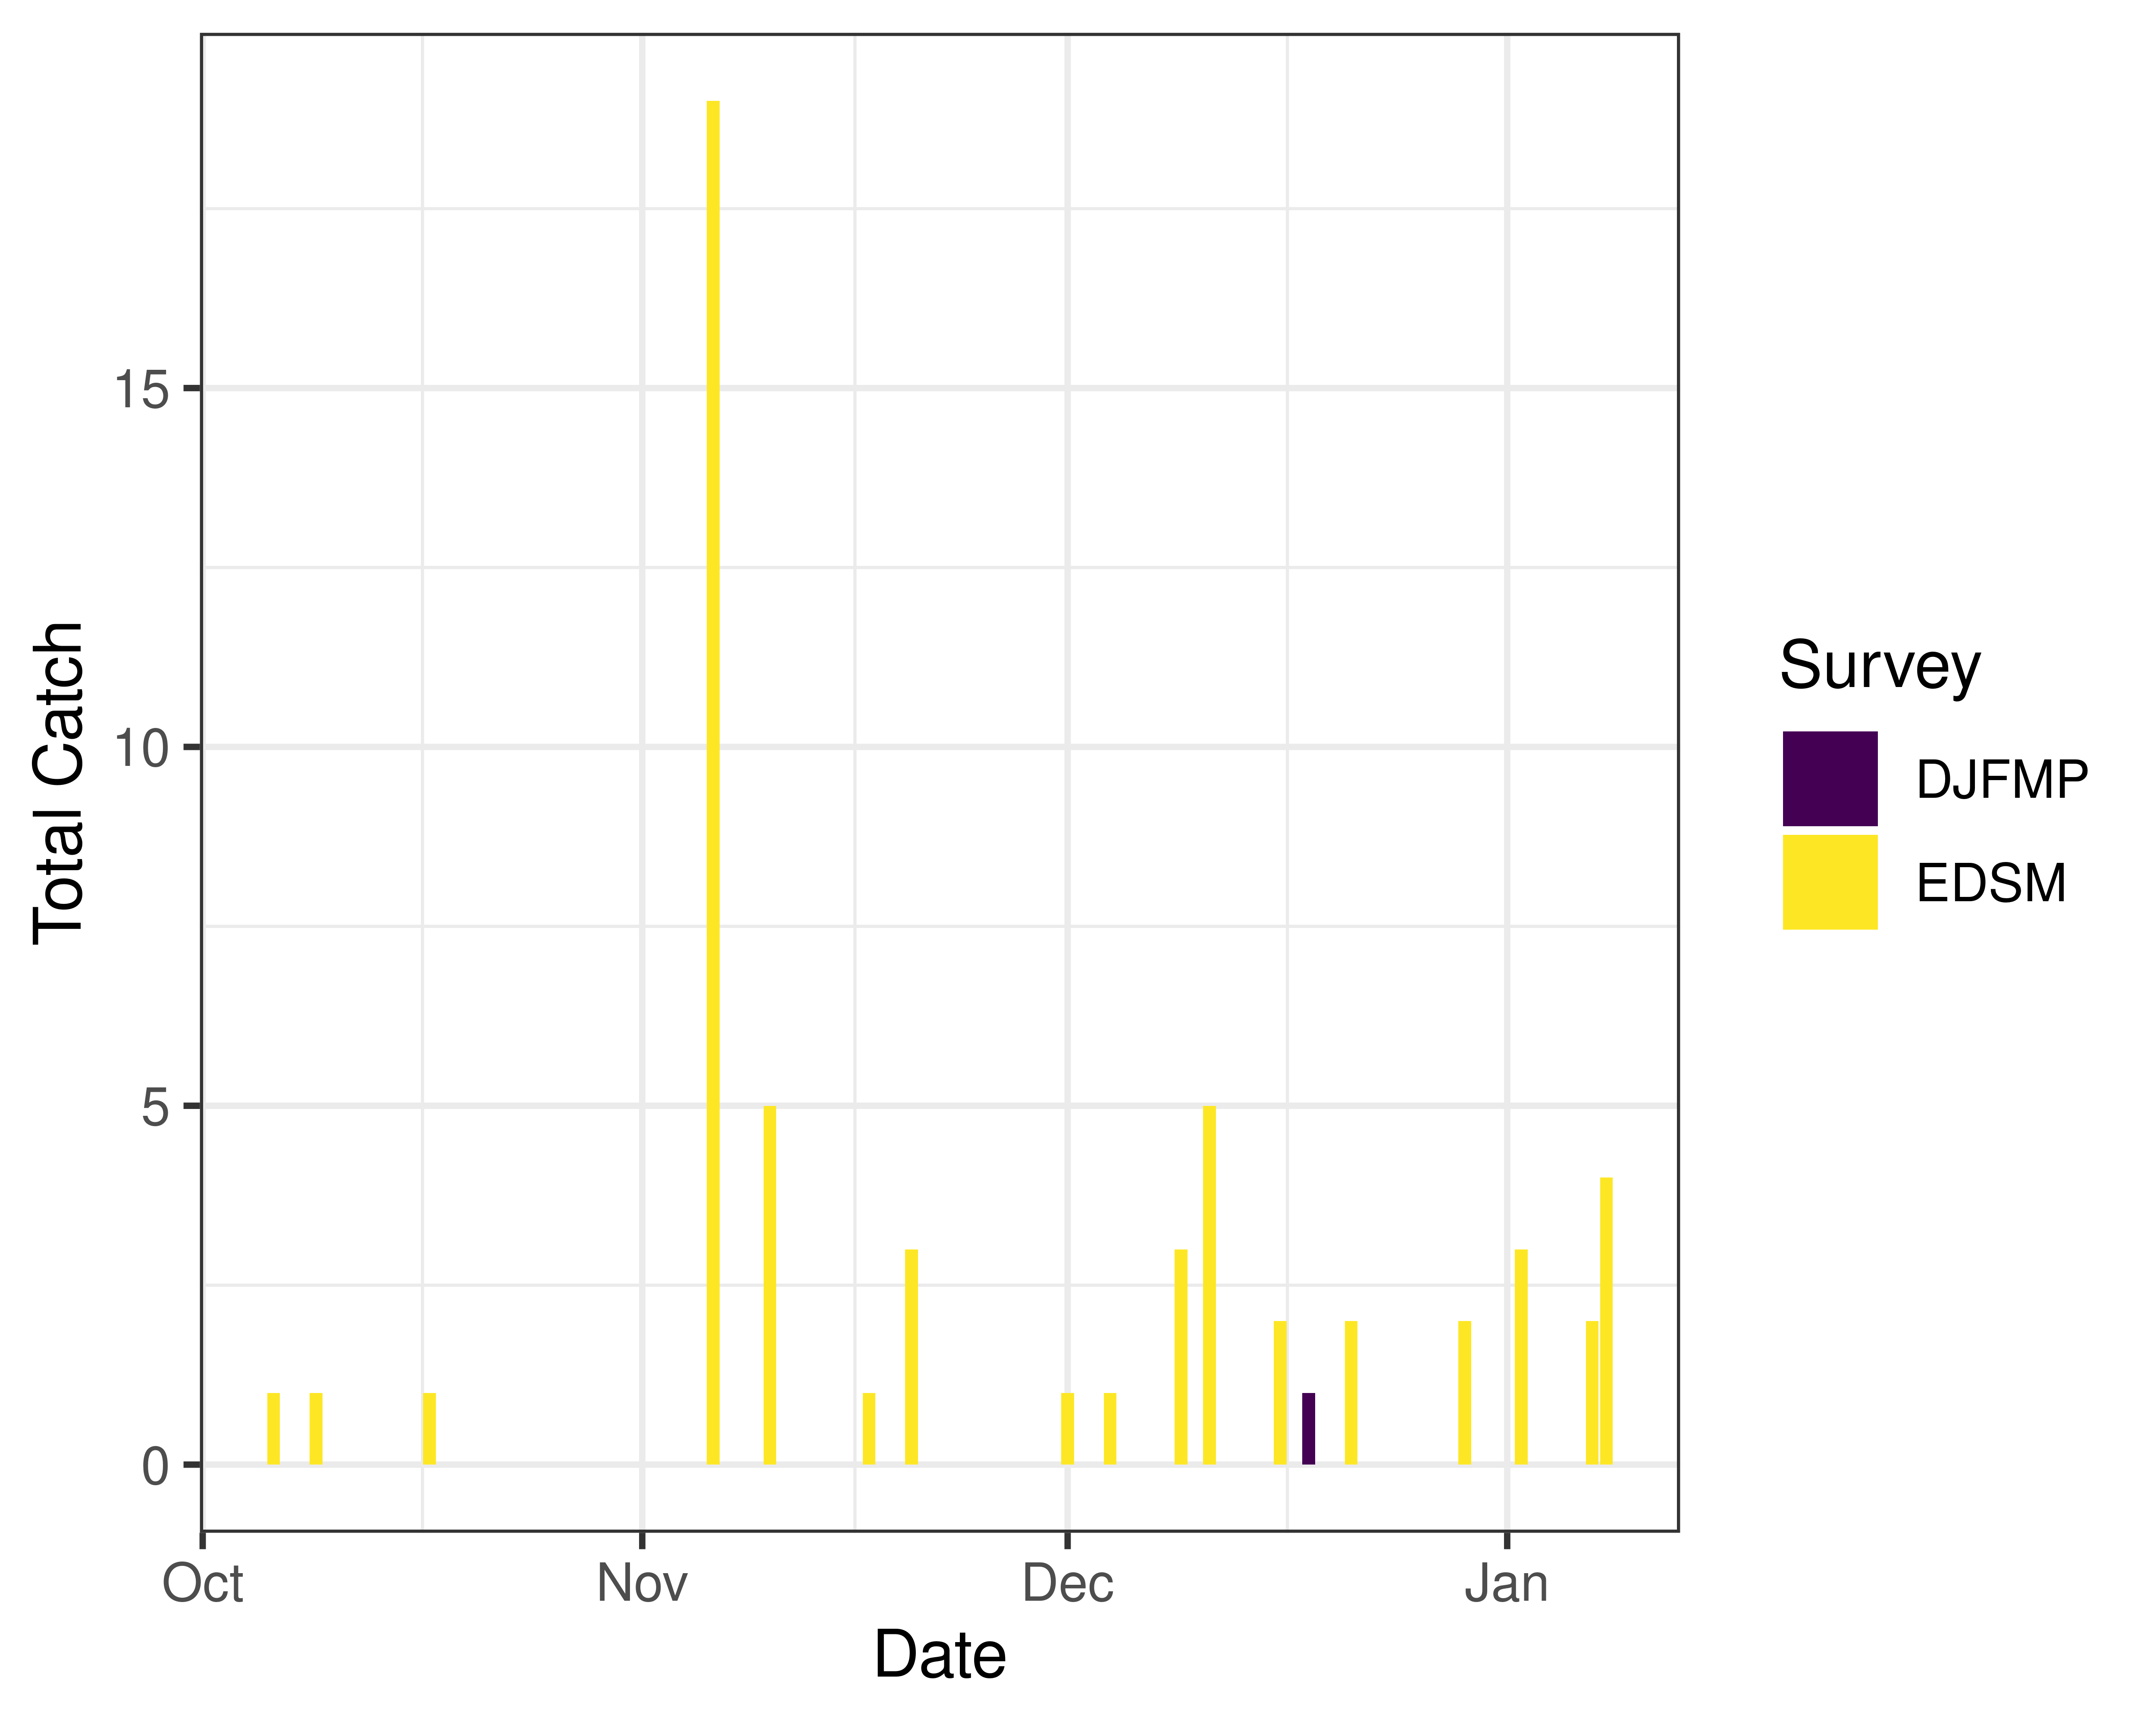
Figure 2: Time series of Delta smelt catch, WY 2026

Environmental

First Flush
- Not relevant

Real-time Assessment Thresholds

Adult Delta smelt
Threshold: If daily average JPF < 0 AND turbidity $≥$ 12 FNU at OBI, HOL and OSJ
- JPF: 9,041 cfs as of Jan 12, 2026
- OBI Turbidity: 6.76, 6.66, 6.46 FNU as of Jan 12, 2026
- HOL Turbidity: 8.52, 7.39, 7.01 FNU as of Jan 12, 2026
- OSJ Turbidity: 15.31, 18.22, 18.8 FNU as of Jan 12, 2026
Offramp Adult Protections when RVB or SJJ > 12$​^{∘}$C
- RVB temperature (3-day average): 9.98$​^{∘}$C as of Jan 12, 2026
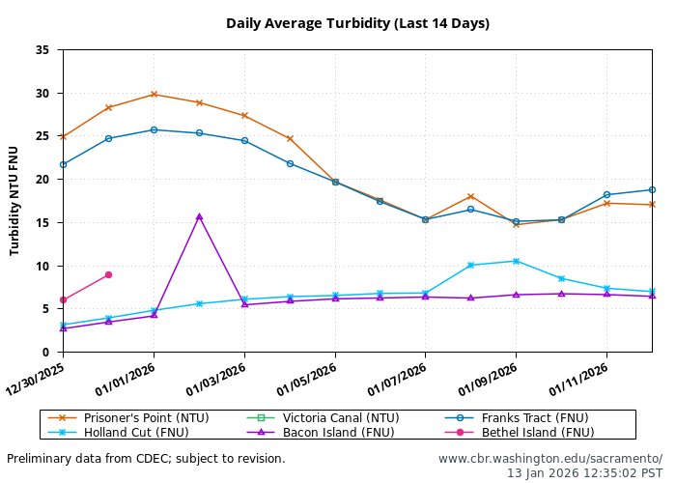
- See Bay-Delta Live for recent Delta-wide turbidity conditions.

Larval/juvenile Delta smelt
Threshold: After the onset of spawning, if JPF < 0 cfs AND turbidity is $≥$ 12 FNU in the south Delta AND PTM modeling indicates the action would avoid $≥$ 5% entrainment of Delta smelt population after 30 days
- 12-station South Delta Turbidity: The most recent average turbidity was 19.1 FNU as of Dec 30, 2025

Evaluation
Delta smelt:
- After the start of entrainment management, is JPF < 0 and is daily average turbidity $≥$ 12 FNU in the OMR corridor (stations OBI, HOL, and OSJ)?
- No, these conditions will not be met this week.
- Has the average water temperature at Jersey Point or Rio Vista not exceeded 53.6$​^{∘}$F (12$​^{∘}$C) for 3 consecutive days and/or has this action already been taken during WY 2026?
- Temperature at Rio Vista or Jersey Point has not exceeded the threshold. The Delta smelt adult entrainment management action has not yet been taken in WY 2026.
- What is the evidence for the onset of Delta smelt spawning?
- Upstream migration for Delta smelt occurs between September and December and in response to “first flush” conditions (Sommer et al. 2011, Grimaldo et al. 2009). Migration typically ranges one to four weeks after flow and turbidity increases, based on salvage data (Sommer et al. 2011). Historically, detections of ripe Delta smelt began in January and peaked in February and March and the majority of Delta Smelt spawning occurs within a temperature range of 9-18˚C (Damon et al. 2016). Based on historical monitoring data from the past few years, first detection of larvae in the Central and South Delta has typically occurred by mid to late March. Because first flush conditions were met on December 23, spawning-related behaviors may begin occurring during the current assessment week, consistent with the typical one- to four-week response window following increased flow and turbidity.
- After the onset of spawning, have the following conditions occurred: $≥$ 5% entrainment of the Delta smelt population at facilities after 30 days?
- Although spawning may begin during the current assessment period, JPF is above 0 cfs; therefore, the conditions required to evaluate larval and juvenile Delta smelt entrainment management are not met.

Longfin smelt

Biological
- Longfin smelt life stages: Juvenile, Adult
- Longfin smelt count: 296 adult, 446 juvenile, and 10 larval longfin smelt have been detected this water year. See Table 3 for recent detections, Figure 3 for spatial distribution, and Figure 4 for temporal distribution.
- Longfin smelt salvage: 0 longfin smelt have been salvaged, and the cumulative seasonal salvage is 0.
Table 3: Longfin smelt detections in the last 2 weeks. Fork Length > 84mm = Adult, Fork Length 20-84mm = Juvenile, Fork Length < 20mm = Larva.
Survey | Date | Region | Stratum | Life Stage | Catch
DJFMP | 2025-12-31 | N/A | Chipps Island | Adult | 44
DJFMP | 2025-12-31 | N/A | Chipps Island | Juvenile | 2
DJFMP | 2026-01-05 | Bay | Bay | Juvenile | 1
DJFMP | 2026-01-05 | N/A | Chipps Island | Adult | 1
DJFMP | 2026-01-06 | N/A | Chipps Island | Adult | 1
DJFMP | 2026-01-08 | N/A | Chipps Island | Adult | 3
EDSM | 2025-12-31 | Far West | Suisun Bay | Adult | 2
EDSM | 2025-12-31 | Far West | Suisun Bay | Juvenile | 1
EDSM | 2026-01-05 | Far West | Suisun Bay | Adult | 2
EDSM | 2026-01-05 | Far West | Suisun Bay | Juvenile | 2
EDSM | 2026-01-06 | West | Suisun Bay | Juvenile | 1
EDSM | 2026-01-07 | West | Suisun Marsh | Juvenile | 1
EDSM | 2026-01-12 | North | Lower Sacramento | Juvenile | 1
EDSM | 2026-01-12 | West | Lower Sacramento | Adult | 19
EDSM | 2026-01-12 | West | Lower Sacramento | Juvenile | 5

Figure 3: Longfin Smelt Distribution for WY 2026
Table 4: Longfin smelt water year totals by life stage
Survey | Region | Life Stage | Total
DJFMP | Bay | Juvenile | 1
DJFMP | N/A | Adult | 240
DJFMP | N/A | Juvenile | 14
EDSM | Far West | Adult | 7
EDSM | Far West | Juvenile | 13
EDSM | North | Juvenile | 1
EDSM | West | Adult | 41
EDSM | West | Juvenile | 80
baystudy | Bay | Adult | 6
baystudy | Bay | Juvenile | 320
baystudy | Far West | Adult | 2
baystudy | Far West | Juvenile | 11
baystudy | West | Juvenile | 6
sls | Far West | Larva | 3
sls | North | Larva | 1
sls | West | Larva | 6

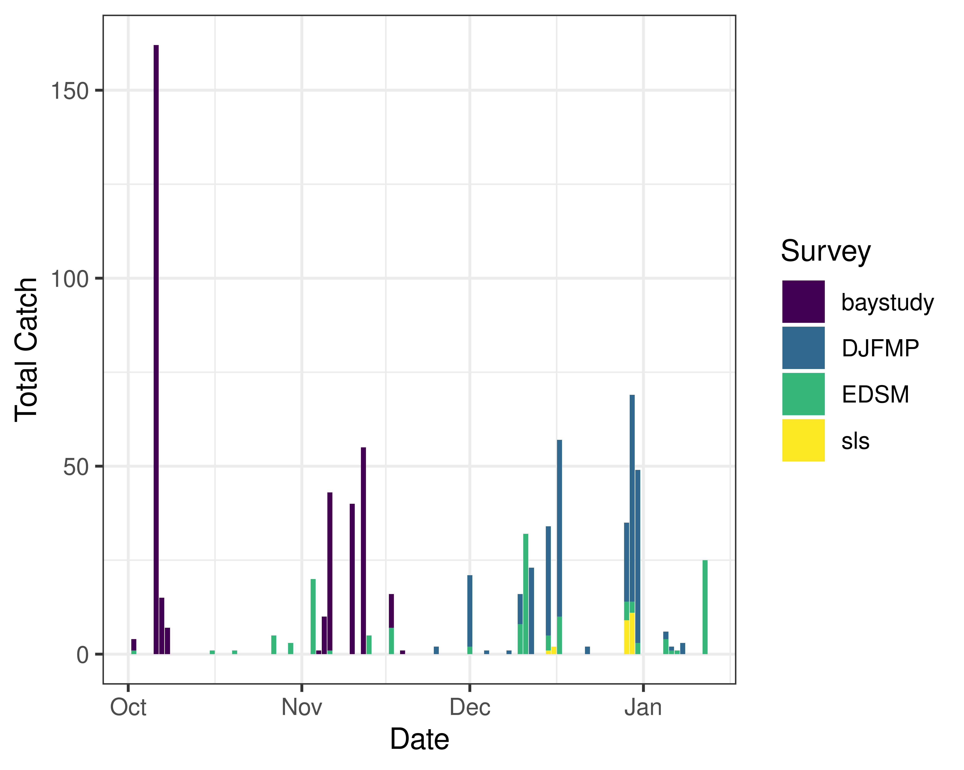
Figure 4: Time series of longfin smelt catch, WY 2026

Real-time Assessment Thresholds

Start of Entrainment Management (Adult Longfin Smelt)
- Not relevant

Adult longfin smelt
- Threshold: JPF < 0 cfs, annual loss is on a trajectory to exceed 5% of the adult population abundance, and reduced exports will reduce entrainment in the south Delta
  - Daily average JPF: 9,041 cfs as of Jan 12, 2026
  - Adult abundance (Age 1+ LFS index): 2479.2 fish
    - 5% of abundance + 1: 125.0
  - Water year total adult longfin smelt salvage = 0

Larval/juvenile longfin smelt
- Threshold: JPF < 0 cfs AND population model demonstrates need to reduce entrainment to avoid population decline
  - Daily average JPF: 9,041 cfs as of Jan 12, 2026

Evaluation
Longfin smelt:
- If JPF < 0, what is the trajectory of annual loss of adult longfin smelt and is it likely to exceed 5% of the adult population estimate? Is South Delta entrainment expected to decrease due to a reduction in export pumping?
- JPF is not < 0 cfs and no adult longfin smelt have been detected in salvage.
- For larval and juvenile longfin smelt, if JPF < 0 cfs, do particle tracking models show a moderate to high difference in particle fates across different OMRI scenarios? Does Zone of Influence modeling show moderate to high changes in hydrodynamic footprint across different OMRI scenarios? Are these effects anticipated to cause a population decline?
- JPF is not less than zero. ZOI modeling shows moderate change in the hydrodynamic footprint between OMRI scenarios.
- Is there additional information or other analyses that should be considered in this evaluation?
- Additional information may be discussed if needed at the DAT call.

End of smelt Entrainment Management
- Not relevant

References
Damon, L. J., S. B. Slater, R. D. Baxter, and R. W. Fujimura. 2016. Fecundity and reproductive potential of wild female Delta smelt in the upper San Francisco Estuary, California. California Fish and Game 102(4):188–210.
Grimaldo, L. F., T. Sommer, N. Van Ark, G. Jones, E. Holland, P. B. Moyle, B. Herbold & P. Smith (2009) Factors Affecting Fish Entrainment into Massive Water Diversions in a Tidal Freshwater Estuary: Can Fish Losses be Managed? North American Journal of Fisheries Management, 29:5, 1253-1270, DOI: 10.1577/M08-062.1
Sommer, T., F. Mejia, M. Nobriga, and L. Grimaldo. 2011. The Spawning Migration of Delta Smelt in the Upper San Francisco Estuary. San Francisco Estuary and Watershed Science 9(2).

